**Sukkur IBA University**



**Software Development Lifecycle**

**Supervisor: Sir Zakariya Jamali**

**Designed By: Dilbar Hussain**

**BSCS-VIII**

Contents

**Introduction of the Document** 2

**Use Case Diagram** 3

**Architecture Design Diagram** 4

Sequence Diagrams 5

**Activity Diagram:** 6

Class Diagram 7

# **Introduction of the Document**

**1.1 Purpose of this Document**

The purpose of this document is to describe my final year project named ”Early Brain Tumor Detection” in detail and a high-level design framework around which to build the final year project named Early Brain Tumor Detection. Moreover, this document gives a thorough insight and knowledge about the project with its objectives, interfaces, operations, and scope to make this understandable. Besides, this document also includes the features of the project and its constraints. This document also states the information about the stakeholders who are involved either directly or indirectly with this project. It also provides a list of requirements against which this project's final version can be tested and from which it can be determined whether I can successfully implement the system according to the design framework.

**1.2 Scope of Document**

For the final year project, my focus is currently limited to just the detection of the brain tumor, for that user will have to get himself registered. The user will be redirected to the login page. From the login page, the user will get redirected to the dashboard once the credentials are verified. From the dashboard, the user can upload the image and submit his response. At submitting the user response, the user gets the result of Early Brain Tumor detection. After that, the user can log out.

# **Use Case Diagram**

To understand and learn more about system requirements, we make use of a methodology that is the use case, which allows us to clarify, analyze, and manage our system requirements. The use case includes a different set of interactions that the user performs with the system and different users in the scope of a specific scenario/ environment or related to a specific goal.

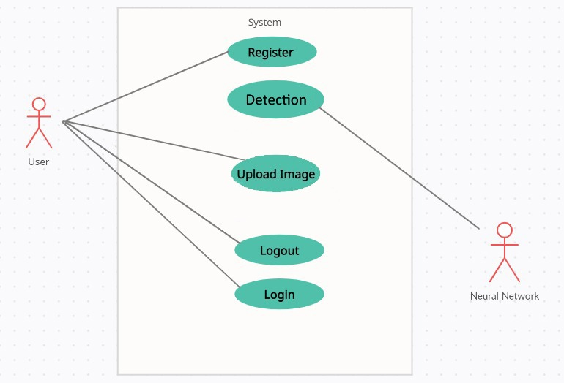

# **Architecture Design Diagram**

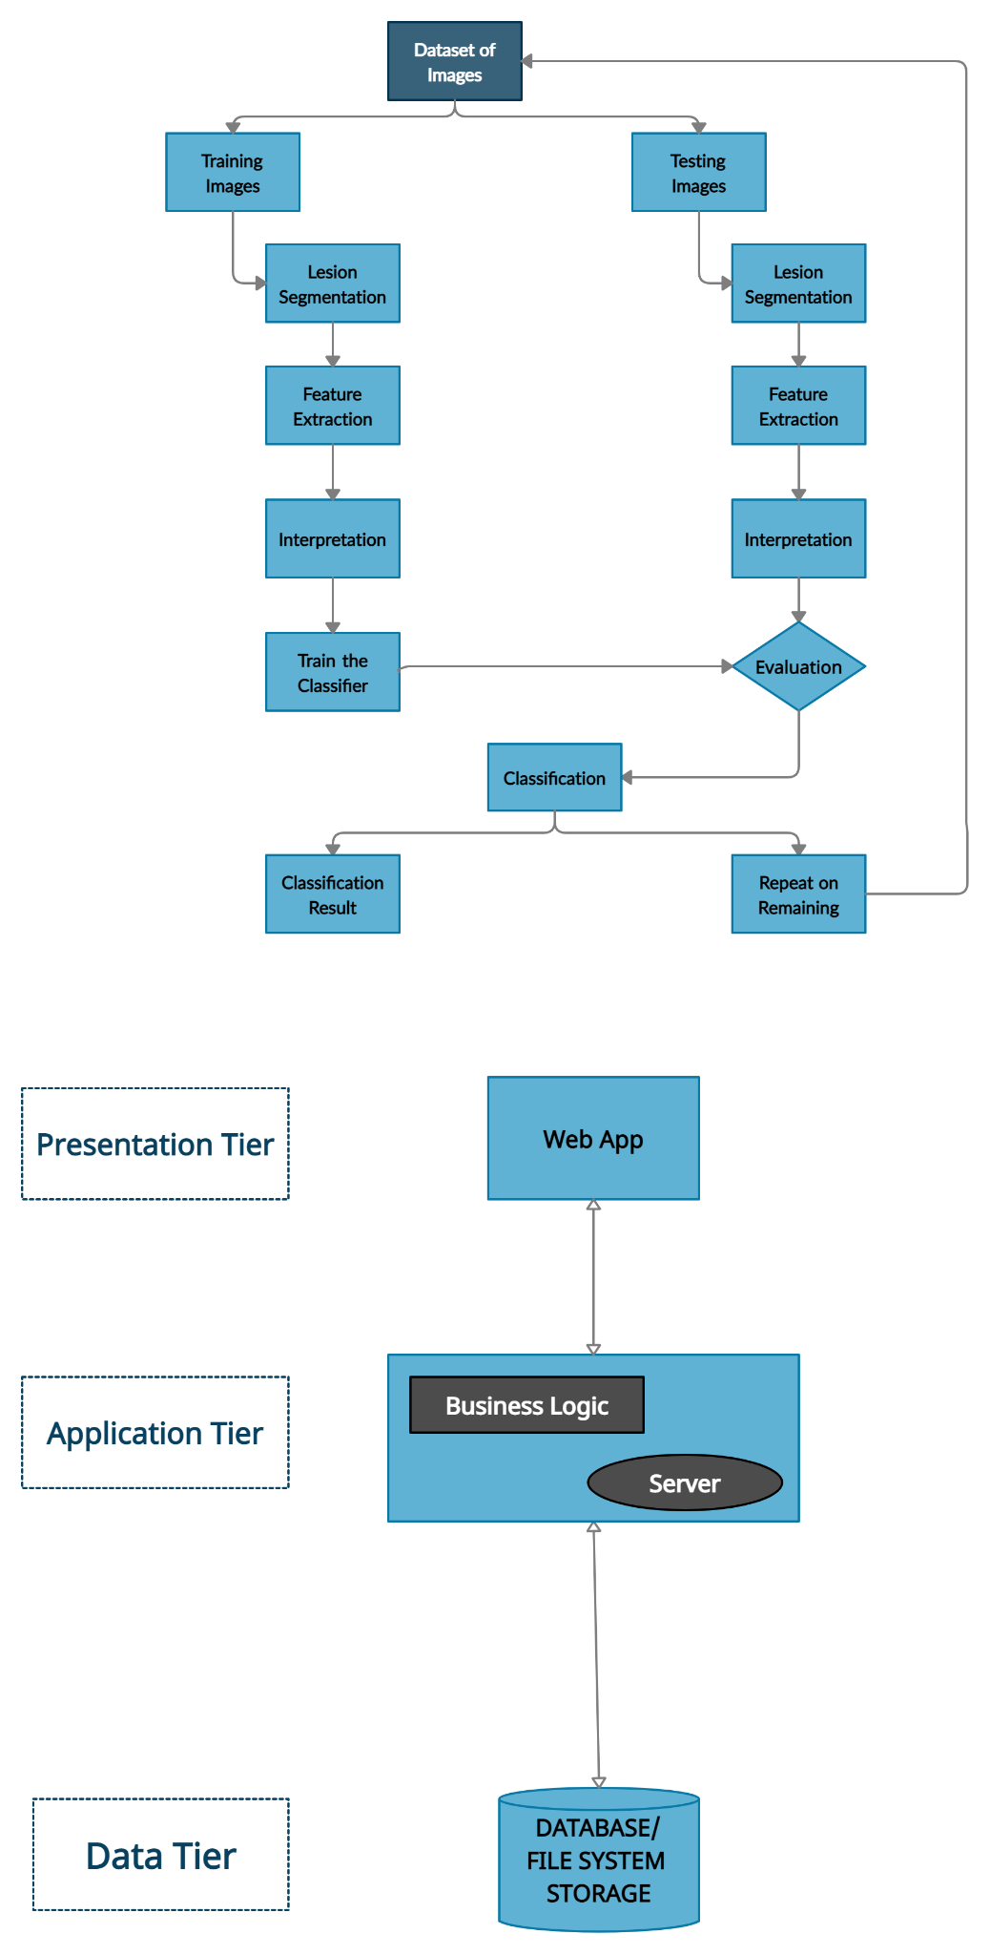

## Sequence Diagrams

The design layout of our web application is explained further using:

* **Sequence diagram: It** explains the interaction between objects in an order in which the actions of the flow take place in the web application.

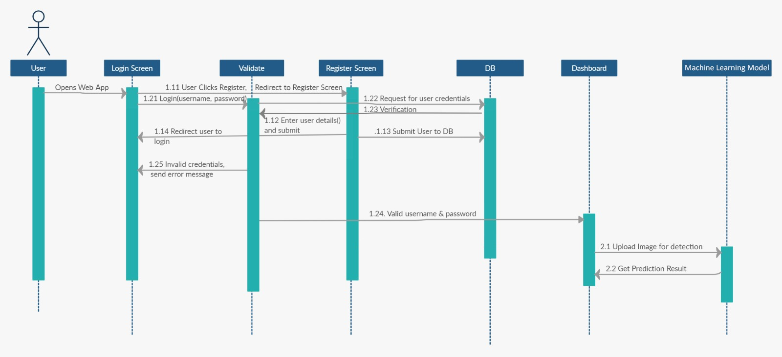

# **Activity Diagram:**

The design layout of our web application, is explained further using the:

* **Activity diagram:** It visually presents a series of actions in the project/web application, It will have an initial state and a final state.

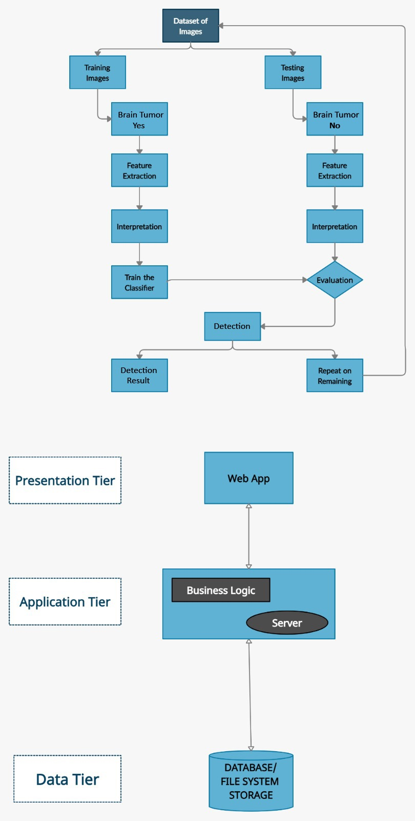

## **Class Diagram**

It helps to make conceptual modeling and detailed modeling to understand how the structure of the application is.

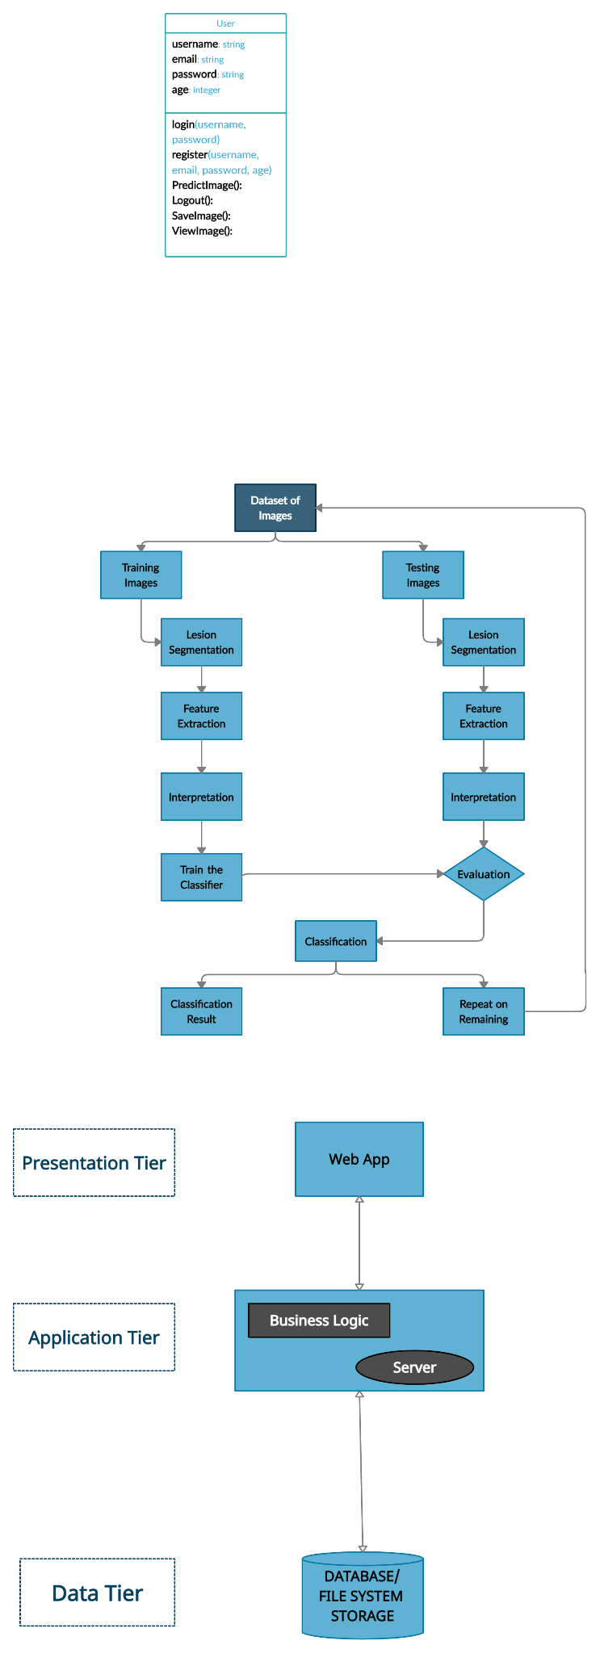

|  |  |  |
| --- | --- | --- |
| **Class Name** | **Attributes of the class** | **Methods of Class and Description** |
| User | username, email, password, age | * Login(): using email and password, the user can log in * Register(): providing different information, the user can register * Detect Image(): if a user is logged in, he can provide an image to detect Early brain tumor detection. * Logout(): The user can log out from the dashboard |

**Relationship between classes:**

There is only one class that is of user.

## 